

BAPTIST CHURCH

May

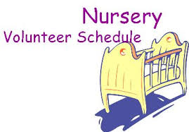
May 7………..…..Judy Broussard, Otisann McManus
May 14……………..…………Jana Moore, Theresa Schane
May 21………..…………..…Angie Fisher, Rachel Merrell
May 28……………………Leigh Veilleux, Terri Edwards
Jan 29…..Terri Edwards, Debby Dunkin

Weekly Service & Activity Schedule:

SUNDAY
Sunday School 9:45 a.m.
Morning Worship Services 11:00 a.m.
Evening Worship Services 6:00 p.m.

WEDNESDAY
Meal/Wednesday Bible Study. 6:30 p.m.

1662 CR 305

McDade, TX 78650

Phone: (512) 273-2743

Email: KnobbsSpringsBaptist@gmail.com



KnobbsSpringsBC.com

David Atwood – Pastor
(512) 470-5098

Patti Radford - Office Manager

KnobbsSpringsBaptist@gmail.com
512-273-2743


May Ushers

Hugo Breithaupt, Kenny Merrell, Jack Radford, Tom Veilleux

May Hostesses/Hosts

Hugo & Carolyn Breithaupt, Bobby & Diann Stutes, Michael & Peggy Hammonds

WHAT’S GOING ON?




Independence Music Festival Sunday May 7 @ 6:00 pm Calvary Baptist Church, Brenham

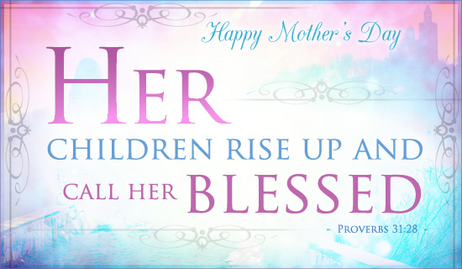

New Commandment Kids
Hands-on mission work thru puppet ministry and crafts to share with nursing homes, shut-ins, etc. Meeting the 1st and 2nd Sunday of each month @9:30 am
Ages Kinder thru 12th grade welcome

May

7…………...……New Commandment Kids

7……………Independence Music Festival
11……….……..…………..Adult Fellowship
14………..…..….New Commandment Kids
14………………..……………Mother’s Day
21………..…Graduate Recognition Lunch
21………………………..Business Meeting
25…………………….……Adult Fellowship
28……………..……Memorial Day Service


Memorial Day Service May 28



Congratulations to the Class of 2017
Join us as we celebrate the graduates of Knobbs Springs Baptist Church with a lunch after the worship service on Sunday May 21
If you have a graduate you would like to recognize contact Bro. David



I just found out something that makes the month of May one of my favorite months! It’s National Barbeque Month! I need to try to celebrate that at least 3 or 4 times this month. It’s also National Hamburger Month, and National Salad Month.

But sincerely, May is a very important month. It means the end of school and the beginning of vacation season; and we celebrate two very important groups of people, mothers on Mother’s Day, and those who have given their life for our country on Memorial Day.
Please pray for all our school children to have a safe Summer, and a prayer of thanks for all of the school employees who took care of our kids with such dedication this school year. Pray for all who will be traveling this Summer.

Each month, we have a lot of opportunities to serve God through service to the church and community. I hope you will take advantage of some of these opportunities to serve. It will be a double blessing!!

God bless you all,
David L. Atwood

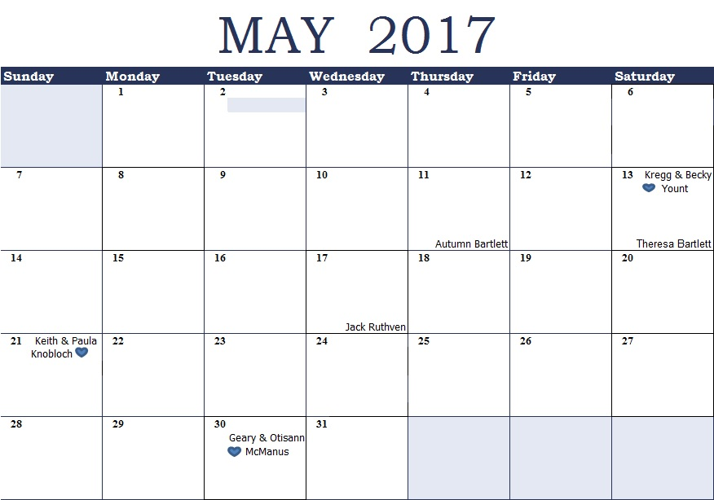
K s b c
Keeping His Word through Sunday School, Bible Study and Church Attendance/Worship
Sunday School Bible Studies for May :
May 7th Life at Home Ephesians 5:22-28, 6:1-3 May 14th Life at Work Colossians 3:22-25, 4:1 May 21st Life in the Community Matthew 25:34-40
May 28th Life on Mission 1 Corinthians 9:19-27

9:45 a.m. each Sunday – A place for everyone
WE’D LOVE FOR YOU TO JOIN US!

